Text 6

I. summarize each paragraph in one sentence or phrase

|  |  |
| --- | --- |
| Text | Summary |
| A recent survey by the Society for Women’s Health Research found that schools often disregard kids’ restroom rights, often by failing to have a bathroom rule on the books and provide staff with education on bladder health. Without official policies, many teachers come up with their own regulations, which anecdotes suggest can border on the absurd. |  |
| Schools seek to minimize the amount of time kids spend in the bathroom during class to ensure that they get the most out of their instruction, and generally restrict students’ access to prevent misconduct in the restrooms, where kids tend to be unsupervised. Well-intentioned yet overburdened teachers might adopt such rules to avoid disruptions and ensure that all their students are accounted for. But treating bathroom use as a discipline issue can have serious health implications, especially when a kid needs to go, but can’t. |  |
| A majority (84 percent) of respondents in the recent survey, which was distributed among school nurses serving all grade levels nationwide, said students often have undisclosed motives when they ask to use the bathroom—maybe they don’t have to go and just want to meet up with a friend, for example, or perhaps they intend to skip the bathroom altogether. A little more than half reported that kids misbehave in the bathroom. Underlying these assumptions is the fact that few schools have written policies on students’ bathroom use, just 8 percent of nurses said such rules existed, while fewer than half said students on their campus can use the bathroom whenever they please, with permission required only as a formality. |  |
| And the survey’s results suggest that such realities persist despite growing recognition of the health consequences. More than a third of respondents expressed concern about the adequacy of kids’ bathroom-break time—and three in four said they were aware of bladder or bowel problems among kids at their school. |  |
| Despite the growing body of empirical research showing that holding it is bad for kids, schools’ mind-sets don’t seem to have changed much. In a 2012 survey, fewer than half of the 600 school nurses who responded suspected that children with frequent urination or bladder and bowel accidents were suffering from an underlying health problem. |  |
| Christopher Cooper, a pediatric urologist at the University of Iowa who co-wrote the 2012 and 2003 studies, began researching the issue. “It started to seem like, if for eight hours a day you [as a teacher] are the primary caregiver for these children, you’re missing a potential opportunity to pick up on some abnormal things going on,” he says. It’s hard for a kid to advance academically and develop socially and emotionally if she is constantly distracted by her bladder troubles. “Wetting your pants at school is one of the most stressful things a child can face or even imagine,” Cooper says. |  |

II. What is the issue?

III. Mind-map

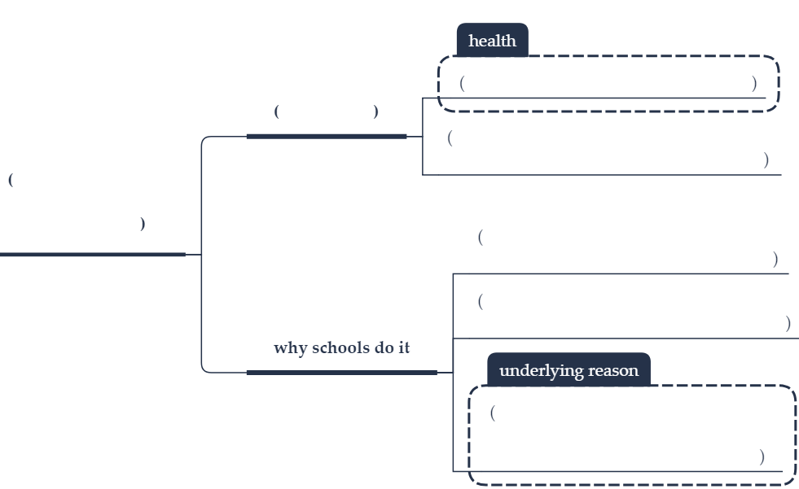

Text 7

I. summarize each paragraph in one sentence or phrase

|  |  |
| --- | --- |
| Text | Summary |
| The danger of so-called “free money” not only underpins critiques of universal basic income (UBI), but also the incredibly strong narratives that underlie the attitudes to work in the UK (and elsewhere) – and our unemployment benefit system. Paid employment is held up as one of the ultimate markers of being a valuable member of society, with those not in paid work (always described in these narratives as a voluntary position, rather than as the result of issues outside their control) seen as a drain on society. Those out of work are positioned in direct contrast to those in paid employment: the “welfare dependent” versus the hardworking families. |  |
| For those in paid work, working hard and being constantly busy are worn as a badge of pride. Work is idealised as providing meaning in our lives, while at the same time removing us from other sources of meaning, such as family, friends and our communities, through long hours and unpaid overtime. |  |
| Preliminary results from Finland’s basic income experiment found little to no impact on recipients’ likelihood of undertaking paid employment. This has led some to suggest that the experiment is a failure – indeed, the Finnish government had hoped the plan would increase participation in paid work. However, although it was not a trial of a full UBI (universal, unconditional, non-withdrawable and non means-tested) it is being celebrated by many who advocate the idea, as it provides important evidence about the interaction of UBI and work. One of the major objections is that getting “free money” would undermine recipients’ motivation to undertake paid work: the Finnish case shows this is not so. |  |
| The notion that paid employment is the cure to all ills has been seriously undermined, if it were ever true. Work as the best route out of poverty may still hold true for some, but the majority of households in poverty in the UK are now consistently those with at least one person in work. The likelihood of people becoming stuck in low-wage, low-skilled work is significant, and hard work among the lower paid is doing nothing to reduce economic inequalities. |  |
| For its proponents, a UBI can provide a lifejacket and a route through some of the challenges. A UBI could provide a stable income floor, a guaranteed minimum below which no one would fall. Depending on the amount paid, it could enable low-paid workers to turn down the worst jobs on offer, or enable time away from paid work to retrain, or start a business. It would financially compensate those (usually women) caring for family for their work, support more people to be creative, to volunteer, or simply to do nothing. |  |

II. What is the issue?

III. Mind-map

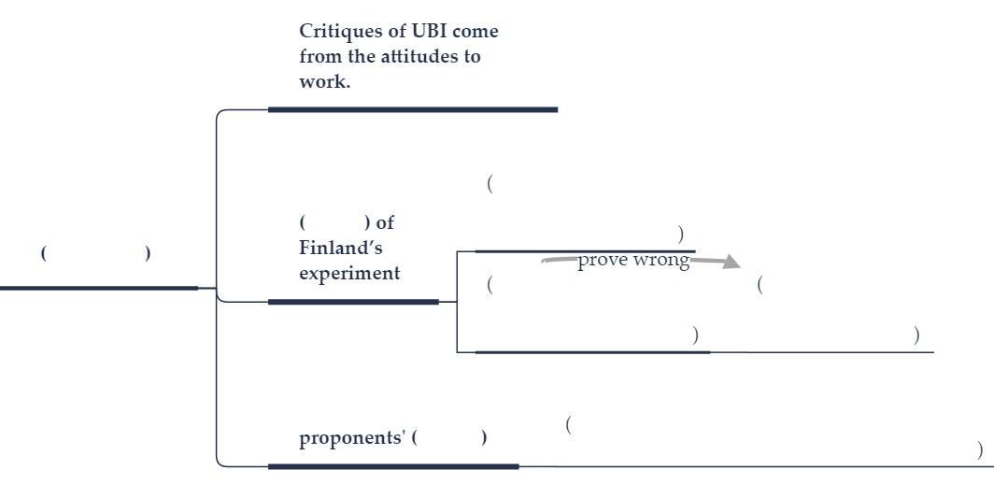

Text 8

I. summarize each paragraph in one sentence or phrase

|  |  |
| --- | --- |
| Text | Summary |
| The government’s teacher recruitment and retention strategy for England contains much that is sensible and desperately needed. Key recruitment targets have been missed for six years in a row. In some subjects, and some parts of the country, shortages are severe. Last year, 10% of all secondary teachers left teaching. Meanwhile, the population eruption that followed the increase in the birthrate in the 2000s means the secondary-school-age population is expected to rise until 2025. The situation is accurately described as a crisis. |  |
| The education secretary, Damian Hinds, has come up with a package of measures that he hopes will ease it. Ministers and inspectors now acknowledge the “unintended consequences” of a system that has accountability as its preeminent objective. One idea is that requirements for data collection should be relaxed, giving teachers more time to think about the substance of what they are teaching. Specific support for new teachers, which the government has promised to fund, includes mentoring and time outside the classroom. Inspectors, in future, will take a broader-brush approach, less focused on the minutiae of individual pupils’ measurable achievements and more on the big picture. |  |
| Whether plans to boost retention bear fruit will depend on whether ministers are right that there is an unmet demand for part-time jobs in teaching. The proposed new matchmaking service for would-be job-sharers is a nice idea, at any rate. Efforts to simplify routes into teaching are also reasonable, as is the focus on career development for classroom teachers who do not want to be managers. Just as valuable as the pragmatic substance of the proposals is the tone in which they are delivered, which is notably more collegiate than that adopted by past education secretaries, both Conservative and Labour. |  |
| That said, there are many problems that this strategy does not begin to address, with funding the most urgent. English schools have faced cuts of 8% in real terms since 2010. Years of public-sector wage freezes have meant salaries have fallen compared with teachers in other countries, as well as other graduate jobs. It may also lead to issues with quality control. Also not addressed is the unsatisfactory state of the many academies that perform worse than the local authority schools they replaced. Unless the government finds a way to tackle such weaknesses in the system, and until it increases funding, standards will suffer. |  |
| It is also questionable to what extent the reforms will return to teachers the professional autonomy that they lack. But the government is at least listening; and taking responsibility for planning for a future in which the number of secondary school pupils is set to increase sharply. |

II. What is the issue?

III. Mind-map

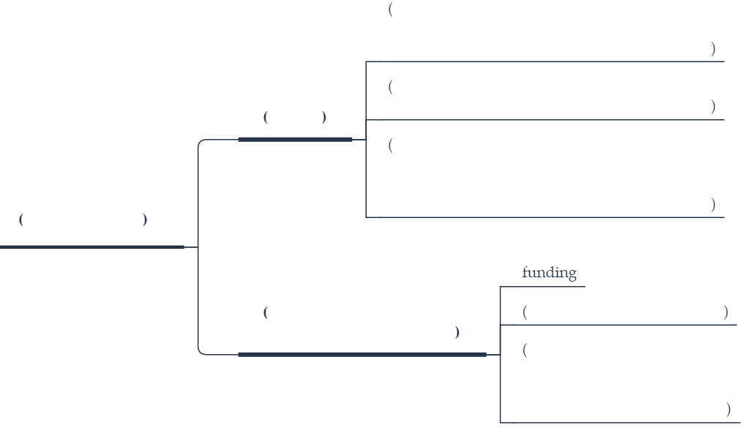

Text 9

I. summarize each paragraph in one sentence or phrase

|  |  |
| --- | --- |
| Text | Summary |
| Last year, when wildfires in California were already breaking records, Gov. Jerry Brown advised the state to accept it as “the new normal.” This November, as the state saw its most destructive fires in history with dozens of people killed, the governor said the fires are instead “the new abnormal.” |  |
| He did not explain his change of terms. Yet the switch nicely wraps up a decades-long debate over whether wildfires are part of a natural order or something to quickly suppress, as Smoky Bear told generations of Americans. |  |
| It also hints at the question of whether humans are disrupting that order – such as with climate change – even as they struggle to find a harmonious place in it. Ancient humans may have “discovered” fire. But we moderns have yet to learn to live with it or deal with how we cause it. |  |
| Compared with other states, California has done well in dealing with an increase in wildfires and in trying to find a balance between human structures and the grasslands, brush, and trees. The state, which is the world’s fifth-largest economy, has been a leader in reducing carbon emissions. It requires nonflammable materials in many new houses and a “defensible space” around homes to keep fires at bay. It has tried to use prescribed or “controlled” burns to get rid of dead vegetation, although not as well as in many Southeast states. |  |
| Like most states, it has not done as well in preventing the sprawl of homes onto the edges of forest and scrub, or what is called the wildlife-urban interface. The rising proximity of people to combustible lands may be the new normal. Yet isn’t it normal for humans to fit into the natural order of wildfires, which have long been necessary to maintain a resilient and balanced ecosystem? |  |
| In wilderness, constant change is the natural order yet humans somehow insist on defining what is good in nature, often demanding wild lands remain the same. As more people build homes near natural settings, the desire for aggressive fire suppression also rises. More government money still goes into fighting forest fires than other aspects of dealing with wildfires, such as zoning or green energy. Nationwide an estimated 46 million homes are in fire-prone areas. |  |
| At many levels of governance, there is still no universal consensus on how to deal with wildfires. “All fire strategies suffer failures and at roughly the same rate,” says fire historian Stephen Pyne, a professor at Arizona State University. |  |
| California’s battle with wildfires represents a mix of different strategies designed to both contain fire and live with it. What is normal or abnormal is not yet clear. But somewhere in the struggle lies the ideal of a natural order, with humans as part of it. | - |

II. What is the issue?

III. Mind-map

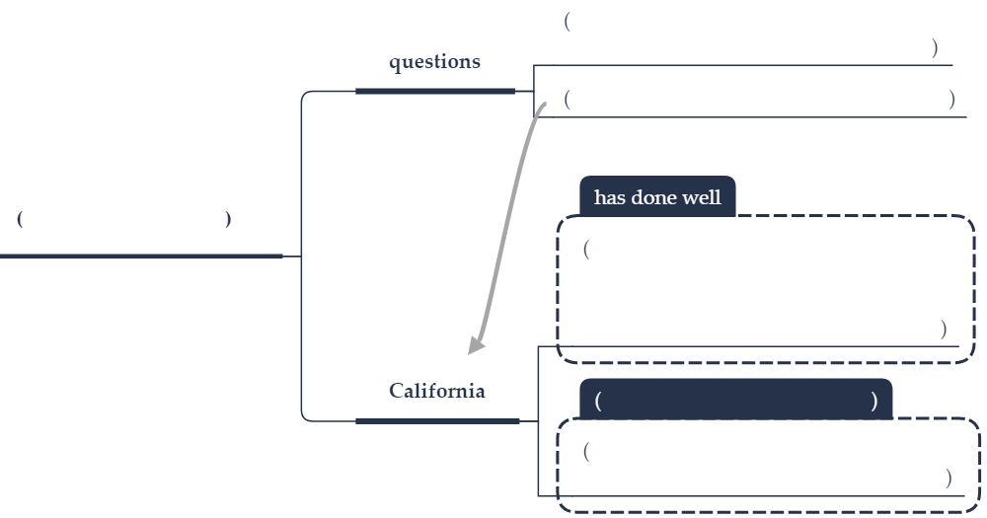

Text 10

I. summarize each paragraph in one sentence or phrase

|  |  |
| --- | --- |
| Text | Summary |
| El Salvador is the smallest Latin American country, yet its presidential election on Feb. 3 is going to be large. The leading candidate in the race, Nayib Bukele, could be the next politician in the region to win office by riding a wave of citizen demand for clean governance. |  |
| A recent poll of Latin Americans showed 70 percent say ordinary people can make a difference in fighting corruption, a trend reflected in the latest elections in Mexico, Brazil, and elsewhere. When he was mayor of El Salvador’s capital, Mr. Bukele tried to tap into that rising public expectation for transparency and accountability in government. He tried to rid local markets of the city’s notorious gangs. Most of all, he sought to solve the country’s sharp rich-poor divide. If you know your neighbors, he often said, you won’t try to kill one another. |  |
| His most popular promise as a presidential candidate is to invite the United Nations to set up a special investigative body in El Salvador. It would be modeled after similar anti-corruption bodies in Guatemala and Honduras that have achieved some success. The country has already made some progress against sticky fingers in high places. Three of the past six presidents have been investigated for corruption. |  |
| A victory by Bukele would also shake up El Salvador’s traditional politics. He would be the first president not to belong to one of two traditional parties. Although once a member of the leading leftist party, he is running on the ticket of a small, center-right party, the Grand Alliance for National Unity, or GANA, which means “win” in Spanish. |  |
| He is making bold promises on public spending, especially on infrastructure, on the idea that controlling corruption will free up tax revenue. His motto: "There is enough money when nobody is stealing." |  |
| A Bukele win would certainly resonate in the United States. About a quarter of El Salvador’s citizens live in the US. Their money account for almost a fifth of the Salvadoran economy. In addition, El Salvador’s notorious gangs, which fed the corruption, have long influences in the US. |  |
| The real debate in the US over border security should be about support for ways to reduce corruption in Central America. The best “wall” against migration is found in candidates like Bukele, who are running on a citizenry awakening to the idea that honesty can be a norm in government. |  |

II. What is the issue?

III. Mind-map

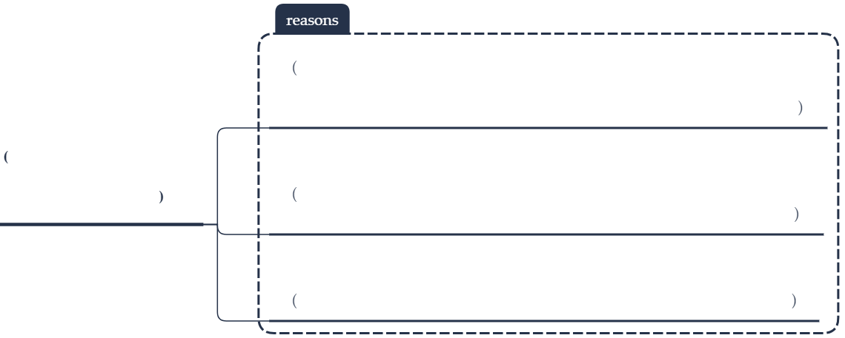

Text 11

I. summarize each paragraph in one sentence or phrase

|  |  |
| --- | --- |
| Text | Summary |
| Two of the biggest investors in Apple sent a letter to the tech giant last week asking it to look at the negative effects of its products on users, principally excessive screen time among children and teens. | - |
| Such public concerns shared by investors about the social consequences of technology on youths may be a first for Silicon Valley. The shareholders and a teachers’ benefits organization, wrote that it is no secret “that social media sites and applications for which the iPhone and iPad are a primary doorway are usually designed to be as addictive and time-consuming as possible, as many of their original creators have publicly acknowledged.” |  |
| The letter asks Apple to have a more sensitive approach to children and to provide better tools to help parents guide their kids. “We believe the long-term health of its youngest customers and the health of society, our economy and the company itself are inseparably linked,” the investors stated. The letter echoes a rising response around the world about the impact of the digital industry on young people – even though many tech firms such as Facebook already have various safeguards in place. |  |
| Last week, the World Health Organization listed “gaming disorder” as a mental health condition, in which excessive video gaming is seen as taking “precedence over other life interests.” South Korea bans access for children under 16 to online games between midnight and 6 a.m. France is weighing a measure to require children under 16 to obtain their parents’ approval to open an account on social media sites. It already plans to ban any use of mobile phones by students in primary and middle schools. |  |
| Such calls for reform are not a rejection of technology but fundamentally an embrace of the innocence of children and a desire to enhance their capacity to self-regulate and to guard their consciousness. They also point to the need for a closer look at how children really use their devices. |  |
| A recent study from the University of Oxford found that children primarily use such technology to enhance their daily activities, such as homework. “People think that children are addicted to technology and in front of these screens 24/7, to the exclusion of other activities – and we now know that is not the case,” says researcher Killian Mullan. |  |
| In addition, adults need to react carefully to their concerns. A study out of the University of Chicago found that teens who voluntarily take breaks from social media fare better in their friendships than teens whose devices are taken away from them. |  |
| The solutions may lie less in Silicon Valley and more in society’s attention to the inherent abilities of children. “We should promote children’s critical spirit and their ability to analyze and distance themselves from over-using their phones,” Rachel Delacour, co-president of industry body France Digital, tells the Financial Times. |  |

II. What is the issue?

III. Mind-map

